DEASE
Devotion Made Easy
Full Stack Development with MERN — Project Documentation
MERN Stack Project • React + Node.js + Express + MongoDB
Prepared: July 2026
Project Title: Darshan Ease – Temple Management and Online Booking System
Technology Stack: MERN (MongoDB, Express.js, React.js, Node.js)
Prepared By: Poornesh Kumar

Introduction

Religious tourism and temple management have become increasingly dependent on digital technologies to improve service quality and enhance the experience of devotees. Traditional methods of managing temple activities such as darshan booking, accommodation allocation, donation management, and special puja reservations often involve long queues, manual paperwork, and administrative delays. These issues create inconvenience for devotees while increasing the workload of temple administrators.
Darshan Ease is a web-based Temple Management System developed using the MERN technology stack to digitize these operations. The system enables devotees to securely register, browse temples, reserve darshan slots, request special pujas, book accommodation, make online donations, and receive QR-code-based entry tickets. Administrators can efficiently monitor bookings, manage temple slots, verify donation requests, and oversee overall temple operations through a centralized dashboard.
The project demonstrates the practical implementation of modern web technologies, secure authentication mechanisms, RESTful APIs, and responsive user interfaces to provide a reliable and scalable temple management solution.

Project Overview

Darshan Ease is designed as a centralized digital platform that bridges the gap between devotees and temple administration. The application automates routine administrative tasks while providing devotees with a seamless online booking experience.
The platform consists of two major components:
Frontend
Developed using React.js and Tailwind CSS, the frontend offers an intuitive and responsive interface for devotees and administrators.
Backend
The backend is developed using Node.js and Express.js and provides RESTful APIs responsible for authentication, booking management, donation handling, and database communication.
Database
MongoDB stores all application data including:
- User Accounts
- Temple Information
- Darshan Slots
- Bookings
- Donations
- Accommodation Requests
The application follows the MVC (Model–View–Controller) architecture to maintain modularity and scalability.

Problem Statement

Many temples continue to rely on traditional manual procedures for managing darshan bookings, accommodation reservations, donations, and administrative records. These methods often result in long waiting times, inefficient resource utilization, and poor record management.
The absence of an integrated digital platform also makes it difficult for devotees to access temple services remotely while increasing the administrative burden on temple authorities.
Darshan Ease addresses these challenges by providing a secure, centralized, and user-friendly digital platform capable of managing all temple-related services efficiently.

Objectives

The primary objectives of Darshan Ease are:
- Digitize temple management operations.
- Provide online darshan slot booking.
- Facilitate special puja reservations.
- Enable online accommodation booking.
- Allow devotees to make secure online donations.
- Generate QR-code-based entry tickets.
- Provide role-based access for Users, Organizers, and Administrators.
- Improve transparency and operational efficiency.
- Reduce manual paperwork and administrative workload.
- Enhance the overall devotee experience.

Scope of the Project

The scope of Darshan Ease includes both devotee-facing services and administrative functionalities.
Devotee Services
- User Registration and Login
- Temple Exploration
- Darshan Booking
- Special Puja Booking
- Accommodation Booking
- Online Donations
- QR Ticket Generation
- Booking History
- Donation History
- Booking Cancellation
Administrative Services
- Temple Management
- Slot Management
- Booking Approval
- Donation Approval
- Dashboard Analytics
- User Monitoring
The system is designed to support future integration with payment gateways, notification services, AI-based recommendations, and mobile applications.

Technologies Used

Category | Technology
Frontend | React.js
Styling | Tailwind CSS
Backend | Node.js
Framework | Express.js
Database | MongoDB
ODM | Mongoose
Authentication | JWT
API Testing | Postman
HTTP Client | Axios
Version Control | Git
Repository | GitHub
Runtime | Node.js
Development Tool | Visual Studio Code

High-Level System Architecture

Architecture Description
The architecture of Darshan Ease follows a three-tier design consisting of:
Presentation Layer
The frontend developed using React.js provides user interaction and communicates with backend services using REST APIs.
Application Layer
The backend developed using Express.js processes client requests, performs authentication, validates business logic, and communicates with the database.
Data Layer
MongoDB stores all persistent application data including users, temples, bookings, slots, donations, and accommodation details.
The modular architecture ensures maintainability, scalability, and ease of future enhancements.

Backend Architecture

8.1 Overview
The backend of Darshan Ease is developed using Node.js and Express.js following the Model-View-Controller (MVC) architectural pattern. This architecture separates business logic, routing, data models, and middleware into independent modules, making the application scalable and maintainable.
The backend exposes RESTful APIs that are consumed by the React frontend. Each request is authenticated using JSON Web Tokens (JWT), validated, processed by the appropriate controller, and stored in MongoDB.

8.2 MVC Architecture
Models
Models represent the database collections and define the schema for each entity.
Major models include:
- User
- Temple
- Slot
- Booking
- Donation
These models are implemented using Mongoose.

Controllers
Controllers contain the business logic of the application.
Major controllers include:
- Authentication Controller
- Temple Controller
- Slot Controller
- Booking Controller
- Donation Controller
Each controller processes requests, validates input, interacts with the database, and returns appropriate responses.

Routes
Routes map HTTP requests to controller functions.
Examples include:
Method | Endpoint | Purpose
POST | /api/auth/login | User Login
POST | /api/auth/register | User Registration
GET | /api/temples | View Temples
GET | /api/bookings | View Bookings
POST | /api/bookings | Create Booking
PUT | /api/bookings/:id/status | Approve Booking
POST | /api/donations | Create Donation

Middleware
Middleware performs tasks before requests reach the controllers.
Implemented middleware includes:
- JWT Authentication
- Role Authorization
- Request Validation
- Error Handling

8.3 Request Flow
The backend processes requests using the following sequence:
- Client sends request
- Route receives request
- Authentication middleware verifies JWT
- Validation middleware checks request data
- Controller executes business logic
- Model interacts with MongoDB
- Response returned to client
This layered approach improves maintainability and security.

Database Design

9.1 Overview
MongoDB is used as the primary database because of its flexibility, scalability, and seamless integration with Node.js through Mongoose.
Collections are designed to minimize redundancy while maintaining efficient relationships.

9.2 Collections
User Collection
Stores information about registered users.
Fields include:
- Name
- Email
- Password
- Role
- Location
Roles supported:
- USER
- ORGANIZER
- ADMIN

Temple Collection
Stores temple information.
Attributes include:
- Temple Name
- Location
- Description
- Images
- Darshan Fee
- Available Pujas

Slot Collection
Stores darshan slot information.
Attributes include:
- Slot Time
- Daily Limit
- Available Seats
- Active Status
Booking Collection
Stores all darshan, accommodation, and puja bookings.
Attributes include:
- User
- Temple
- Slot
- Booking Date
- Number of Persons
- Status
- QR Ticket
Booking status includes:
- PENDING
- BOOKED
- CANCELLED

Donation Collection
Stores donation information.
Fields include:
- User
- Temple
- Amount
- Donation Message
- Anonymous Status
- Payment Status
Payment status includes:
- PENDING
- SUCCESS
- FAILED

Folder Structure

The project is divided into frontend and backend directories.
Darshan-Ease/
│
├── client/
| ├── src/
│ │ └── components/
│ ├ └── context/
│ └── index.html
│
├── server/
│ ├── config/
│ │ └── database.js
│ ├── controllers/
│ ├── middleware/
│ ├── models/
│ ├── routes/
│ ├── validators/
│ ├── server.js
│ └── package.json
│
├── package.json
├── .gitignore
└── README.md

Installation & Setup

Prerequisites
Before running the project, ensure the following software is installed:
- Node.js
- npm
- MongoDB
- Git
- Visual Studio Code

Installation Steps
Clone Repository
git clone https://github.com/poorneshkumar68183-dotcom/DEASE.git

Install Dependencies
npm install

Configure Environment Variables
Create a .env file inside the server directory.
Example:
APP_URL=your_application_url

MONGODB_URI=your_mongodb_connection_string

Run Application
The project supports running both frontend and backend using a single command from the root directory.
npm run dev

Running the Application

Darshan Ease has been configured to simplify development by allowing both frontend and backend services to run simultaneously.
The command
npm run dev
automatically starts:
- React Frontend
- Express Backend
The frontend communicates with backend REST APIs, which in turn interact with MongoDB.

API Documentation

The application exposes RESTful APIs following standard HTTP conventions.
Authentication APIs
Method | Endpoint | Description
POST | /api/auth/register | Register User
POST | /api/auth/login | Login User

Temple APIs
Method | Endpoint | Description
GET | /api/temples | Fetch Temples
GET | /api/temples/:id | Temple Details

Slot APIs
Method | Endpoint | Description
GET | /api/temples/:id/slots | Available Slots
PUT | /api/slots/:id | Update Slot

Booking APIs
Method | Endpoint | Description
POST | /api/bookings | Create Booking
GET | /api/bookings | View Bookings
PUT | /api/bookings/:id/status | Approve Booking
PUT | /api/bookings/:id/cancel | Cancel Booking

Donation APIs
Method | Endpoint | Description
POST | /api/donations | Create Donation
GET | /api/donations | View Donations
PUT | /api/donations/:id/status | Update Donation Status

Authentication & Authorization

14.1 Overview
Darshan Ease implements a secure authentication and authorization mechanism using JSON Web Tokens (JWT). The authentication process ensures that only registered users can access protected resources, while role-based authorization controls access to administrative features.
Passwords are securely encrypted before storage, ensuring user credentials remain protected.

14.2 User Registration
New users can create an account by providing:
- Full Name
- Email Address
- Password
- Role
- Location
During registration:
- Input fields are validated.
- Duplicate email addresses are rejected.
- Passwords are encrypted.
- User details are stored in MongoDB.
After successful registration, users can log in using their credentials.

14.3 User Login
The login module verifies the user's credentials against the database.
Successful authentication results in:
- JWT Token Generation
- User Information Retrieval
- Secure Session Creation
The JWT token is attached to subsequent API requests for authentication.

14.4 Role-Based Authorization
Darshan Ease supports three user roles.
USER
Permissions include:
- View temples
- Book darshan
- Book accommodation
- Request special pujas
- Make donations
- View booking history
- Cancel pending bookings

ORGANIZER
Permissions include:
- Manage temple slots
- View bookings
- Assist administrators

ADMIN
Permissions include:
- Manage temples
- Manage slots
- Approve bookings
- Reject bookings
- Approve donations
- Reject donations
- Dashboard analytics
- Monitor users

14.5 Security Features
The system incorporates multiple security mechanisms:
- JWT Authentication
- Password Encryption
- Protected API Routes
- Role Verification
- Input Validation
- Secure Database Access
These measures protect the application against unauthorized access.

Module Description

Darshan Ease is divided into several functional modules.

15.1 User Module
The User Module manages user registration, authentication, and profile management.
Major features include:
- Registration
- Login
- Profile Management
- Booking History
- Donation History

15.2 Temple Module
The Temple Module provides complete temple information.
Users can:
- Browse temples
- View descriptions
- View available pujas
- View accommodation
- View darshan charges

15.3 Darshan Booking Module
This module allows devotees to reserve darshan slots online.
Workflow:
- Select Temple
- Choose Date
- Select Slot
- Enter Number of Persons
- Confirm Booking
- Generate QR Ticket
The booking is stored in MongoDB and reflected in the user's profile.

15.4 Special Puja Module
Users can request special pujas offered by the selected temple.
Workflow:
- Select Temple
- Choose Puja
- Confirm Booking
The administrator reviews and approves the request.

15.5 Accommodation Module
Devotees can reserve Dharamshala accommodation.
Features:
- View Availability
- Reserve Rooms
- Booking Confirmation

15.6 Donation Module
The donation module enables secure online donations.
Features include:
- Donation Amount
- Anonymous Donation
- Donation Message
- Payment Status
- Donation History
Administrators approve or reject donations through the dashboard.

15.7 Profile Module
The profile page displays all user activities.
Features:
- Active Bookings
- Booking History
- QR Ticket
- Donation History
- Booking Cancellation

15.8 Admin Dashboard
The Admin Dashboard is the control center of the application.
Features include:
- Temple Management
- Slot Management
- Booking Approval
- Donation Approval
- Dashboard Statistics
- Capacity Monitoring

User Interface Description

The application provides a modern and responsive user interface developed using React.js and Tailwind CSS,Bootstrap.
Each page is designed to ensure simplicity, accessibility, and ease of navigation.
Home Page

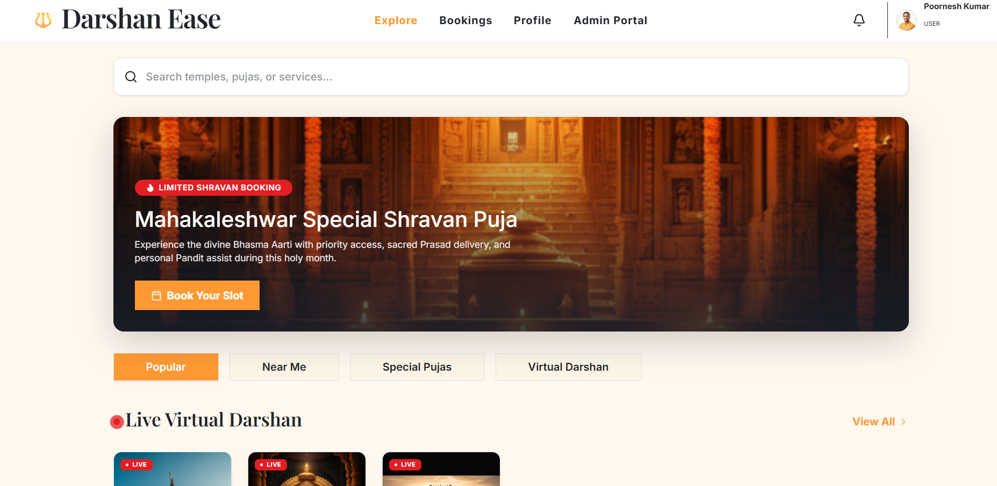

Description:
- Hero Banner
- Featured Temples
- Search
- Navigation
- Quick Actions

Temple Details Page

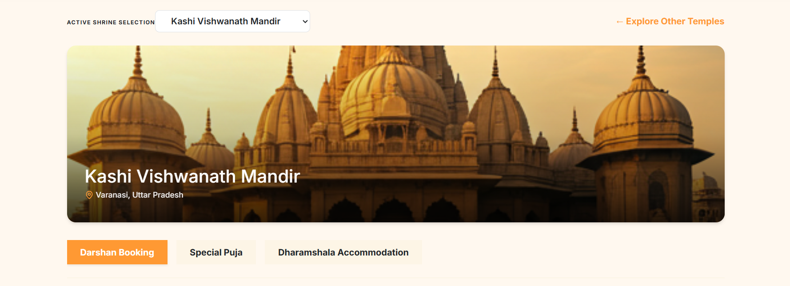
Description:
- Temple Information
- Darshan Details
- Puja Details
- Accommodation Details

Booking Page
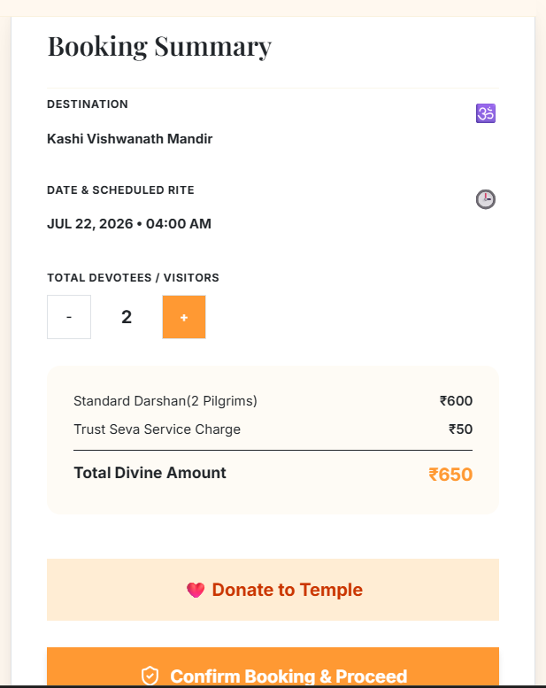

Description:
- Slot Selection
- Number of Persons
- Booking Confirmation
- QR Ticket Generation

Donation Module

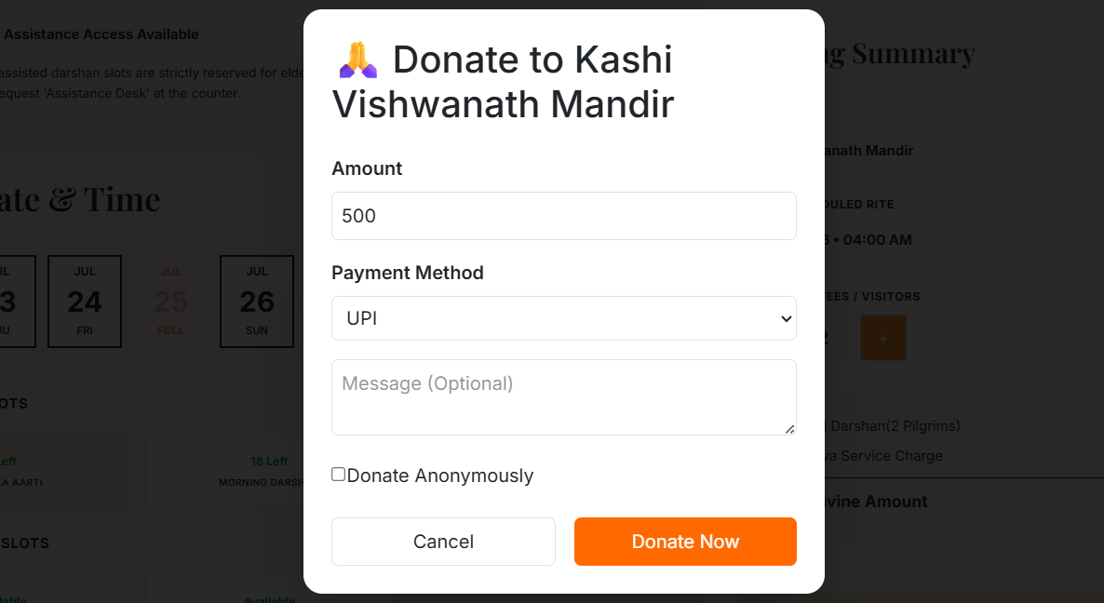
Description:
- Amount Selection
- Anonymous Donation
- Donation Message
- Payment Confirmation

User Profile

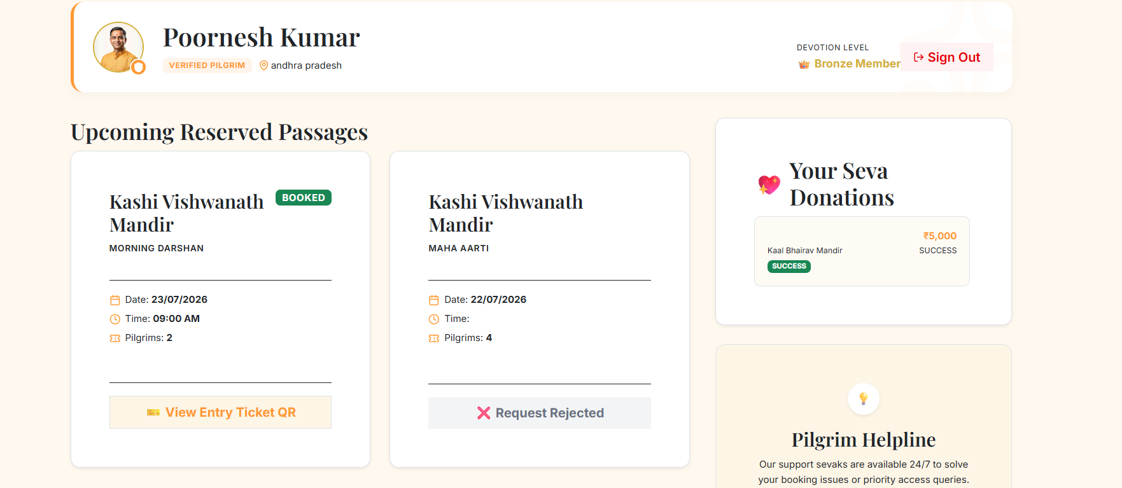
Description:
- Active Bookings
- Booking History
- Donation History
- QR Ticket

Admin Dashboard
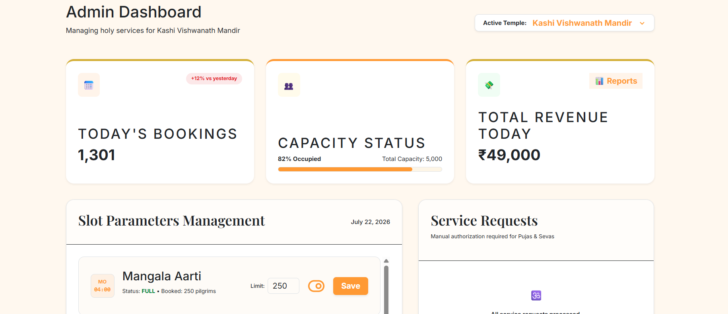

Description:
- Dashboard Statistics
- Pending Requests
- Slot Management
- Donation Approval
- Booking Approval

Testing

The application was tested using both manual and functional testing techniques.
Testing ensured reliability, correctness, and usability.

Functional Testing
The following modules were tested:
Module | Result
User Registration | Passed
Login | Passed
Temple Listing | Passed
Darshan Booking | Passed
QR Ticket | Passed
Donation Module | Passed
Profile Page | Passed
Booking Cancellation | Passed
Admin Dashboard | Passed
Slot Management | Passed

Validation Testing
Input validation includes:
- Required fields
- Email validation
- Password validation
- Duplicate email detection
- Booking validation
- Donation validation

Security Testing
Security testing confirmed:
- JWT Authentication
- Protected Routes
- Role Authorization
- Unauthorized Access Prevention
Browser Compatibility
The application was successfully tested on:
- Google Chrome
- Microsoft Edge
- Mozilla Firefox

Known Issues

Although the application is fully functional, a few limitations remain:
- Payment gateway is simulated.
- Email notifications are not yet implemented.
- SMS notifications are not available.
- Internet connection is required.
- Offline mode is not supported.
- Mobile application is not yet developed.

Future Enhancements

Although Darshan Ease successfully addresses the current requirements of temple management, there are several opportunities to enhance the system further. These improvements will increase usability, scalability, security, and user engagement.
19.1 Online Payment Gateway Integration
Currently, the donation module simulates payment transactions. In future versions, secure payment gateways such as Razorpay, Stripe, or PayPal can be integrated to enable real-time online payments for:
- Darshan bookings
- Accommodation reservations
- Special pujas
- Temple donations

19.2 Email Notifications
Automatic email notifications can be implemented to inform devotees about:
- Booking confirmations
- Donation acknowledgements
- QR ticket delivery
- Booking cancellations
- Special puja approvals
This feature will improve communication between the temple administration and devotees.

19.3 SMS Notifications
Integration with SMS gateways can provide instant updates regarding:
- Booking status
- Darshan reminders
- Donation receipts
- Slot availability
This ensures devotees remain informed even without accessing the application.

19.4 Mobile Application
A dedicated Android and iOS mobile application can be developed using React Native or Flutter.
The mobile application would provide:
- Faster booking
- Push notifications
- QR ticket storage
- Offline ticket viewing
- Improved accessibility
19.5 AI-Based Recommendation System

Artificial Intelligence can enhance the user experience by recommending:
- Nearby temples
- Popular temples
- Suggested darshan timings
- Recommended special pujas
- Personalized devotional content
Machine learning techniques can analyze user preferences to generate personalized recommendations.

19.6 Multi-Language Support
To make the application accessible to devotees across India, multilingual support can be introduced.
Languages may include:
- English
- Telugu
- Hindi
- Tamil
- Kannada
- Malayalam
This will significantly improve usability for regional users.

19.7 Advanced Analytics Dashboard
Future versions may include interactive dashboards displaying:
- Daily bookings
- Monthly revenue
- Popular temples
- Donation trends
- Peak booking hours
- Capacity utilization
These reports will help temple administrators make informed decisions.

19.8 Cloud Deployment
The application can be deployed on cloud platforms such as:
- AWS
- Microsoft Azure
- Google Cloud Platform
- Render
- Railway
- Vercel
Cloud deployment improves scalability, availability, and disaster recovery.

19.9 QR Ticket Verification
QR code scanning devices can be deployed at temple entrances to automatically verify devotees' booking details, reducing manual verification and improving entry efficiency.

19.10 Security Enhancements
Future security improvements include:
- Two-Factor Authentication (2FA)
- CAPTCHA integration
- Rate limiting
- Session timeout
- Activity logging
- Audit trails
These enhancements will further strengthen application security.

Conclusion

Darshan Ease successfully demonstrates the implementation of a modern, secure, and scalable temple management system using the MERN technology stack.
The project effectively digitizes major temple services including:
- Online darshan booking
- Special puja reservation
- Accommodation booking
- Online donations
- QR-code-based entry ticket generation
- Administrative management
The application reduces manual work, improves transparency, enhances user convenience, and provides a centralized platform for temple administration.
By employing technologies such as React.js, Node.js, Express.js, MongoDB, and JWT authentication, the project showcases industry-standard practices in full-stack web development.
The modular architecture ensures that future enhancements can be integrated with minimal modifications, making Darshan Ease a scalable and maintainable solution for digital temple management.
Overall, the project successfully fulfills its objectives and demonstrates the practical application of MERN Stack technologies in solving real-world administrative challenges.

